**Final Project**

**Team Members**

|  |  |  |  |
| --- | --- | --- | --- |
| **Full Name** | **Sec.** | **BN** | **Role in the project** |
| **Mohammed Ibrahim GabAllah** | **2** | **14** | **Task1(a, b, c) & Task3(a) & coordination between members & drawing the figures of task 1 and decorating them & playing the audio files &documenting(task1(all),task3(a)) & documentation merging.** |
| **Mahmoud Amr Nabil** | **2** | **26** | **Task1(d,e) & Task3(e,f) & output audio files for user in task 1** |
| **Mahmoud Medhat Yamani** | **2** | 27 | **Task2(a,c) , the resampling function ,& the graphs.** |
| **Youssef Mahmoud Abdelmonem** | **2** | 35 | **Task2(b,d)& the filtering function** |
| **Mohamed Abo-Bakr Gad El-Karim** | **2** | **15** | **Task3(b,c,d) compressing and decompressing and comparing the sizes in task 3** |

Table of contents:

Project Tasks:

Task One: Echo generation and removal 3

Task Two: Audio steganography 4

Task Three: Image compression 5

Appendices 6

Appendix A: Codes for Task One: 8

Appendix B: Codes for Task Two: 11

Appendix C: Codes for Task Three: 17

References: 20

**List of Figures**

Figure 1: The audio with and before adding echo………………………………………………………………………………………………….3

Figure 2: Impulse response of echo the system……………………………………………………………………………………………………. 3

Figure 3: Manipulated Audio files signals. you will find them in the folder of task 1……………………………………………. 3

Figure 4: Audio Steganography………………………………………….……………………………………………. 4

Figure 5: Image compressed with m = 1…………………………………………………………………………………………………………. 5

Figure 6: Image compressed with m = 2……………………………………………………………..……………………………………. 5

Figure 7: Image compressed with m = 3……………………………………………………………………………………………………. 5

Figure 8: Image compressed with m = 4……………………………………………………………………………………………………. 5

Figure 9: Three components of image red, green and blue from left to right.……………………………………………. 6

# Project Tasks:

## Task One: Echo generation and removal

* See appendix A for info about how to run the code
* GitHub link to the code and output files(“<https://github.com/marait123/Signals-Final/tree/master/1st-task>”)
* You will find in the previous link the sound files after echo and after echo removal
* The python script of task 1 draws the audio signal before and after echo in 1 figure that is displayed
* Figure 1 shows the audio x(t) before adding the echo and y(t) after adding the echo
* Figure 2 shows the impulse response of the system
* The python script also save the audio files before echo adding and after echo adding and after echo removal

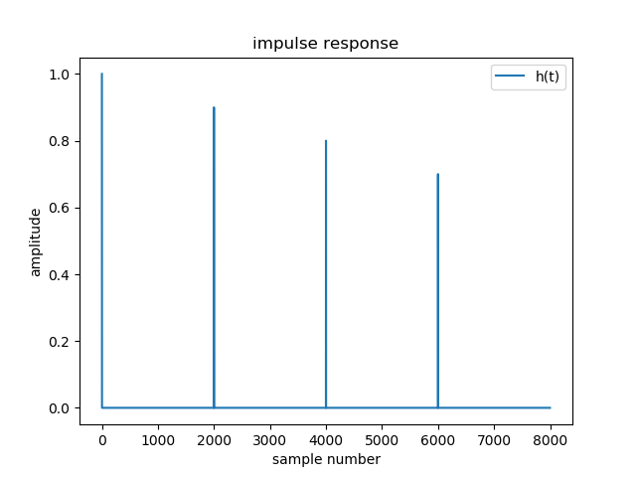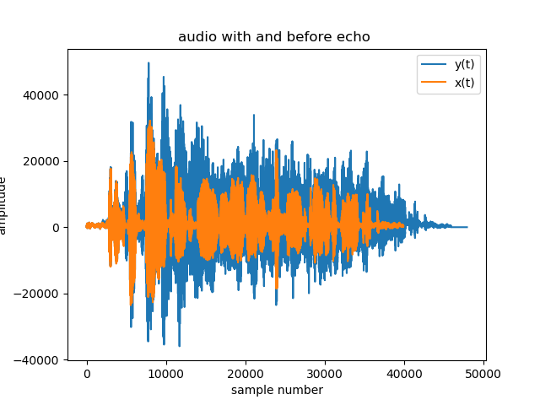

Figure 1

The audio with and before adding echo

Figure 2

Impulse response of echo the system

Figure 3

Manipulated audio files(signals). you will find them in the folder of task 1 in the accompanying link .







Figure 1: Example

## Task Two: Audio steganography

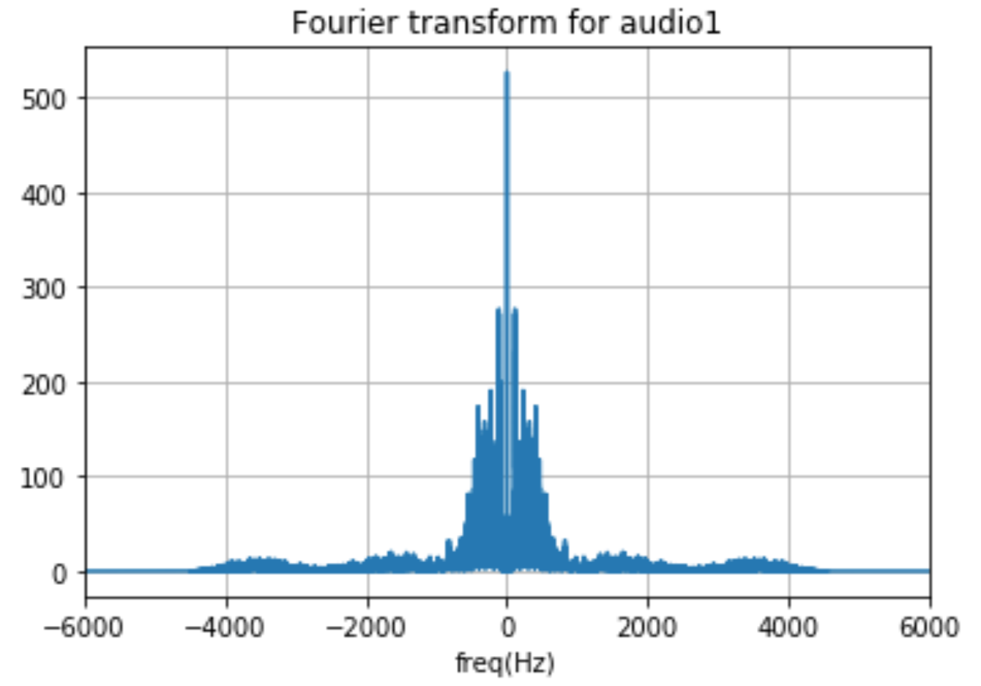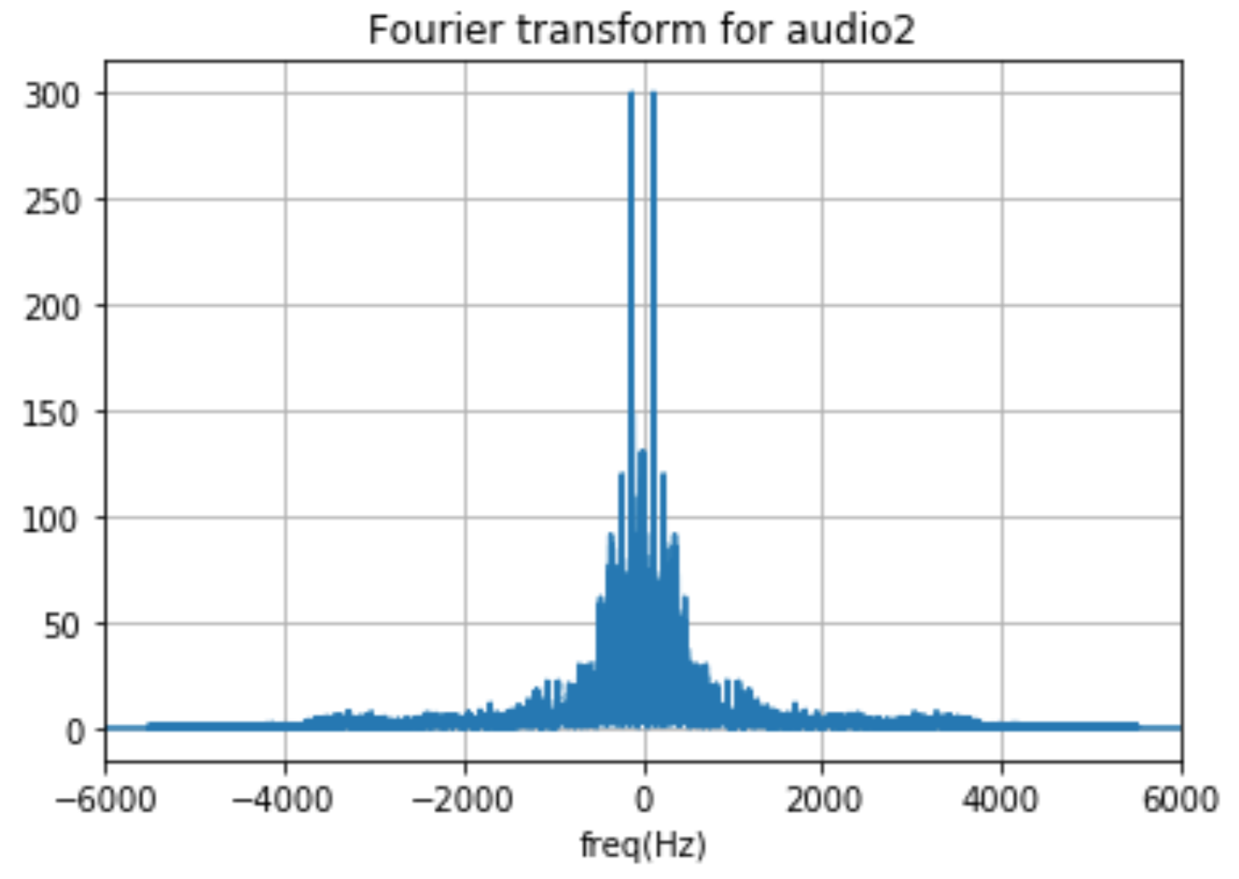

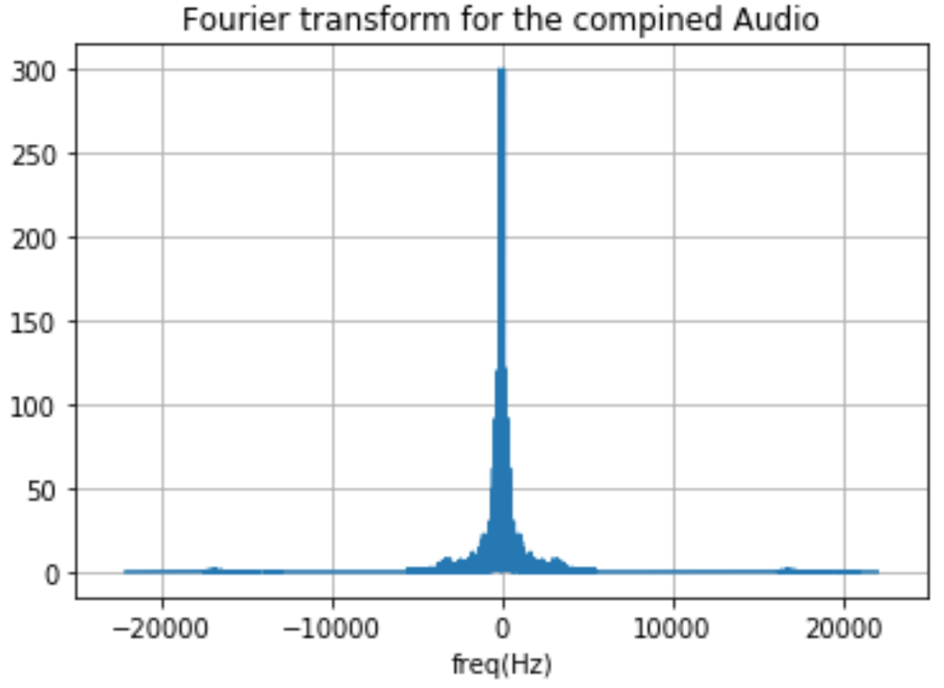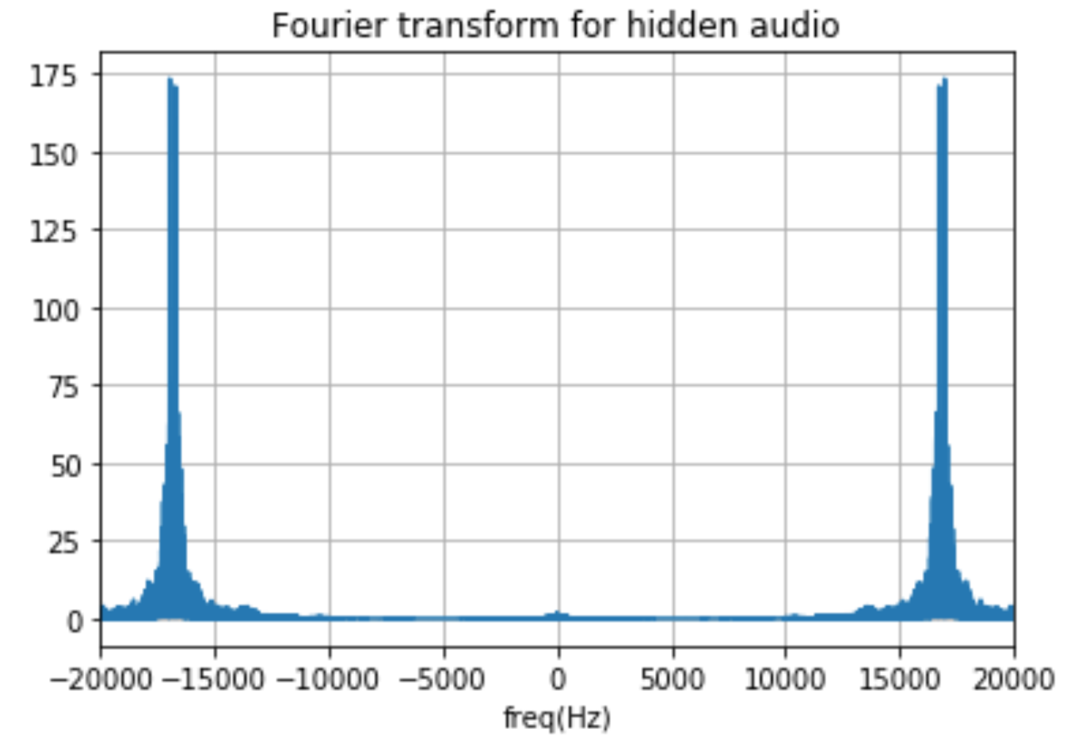

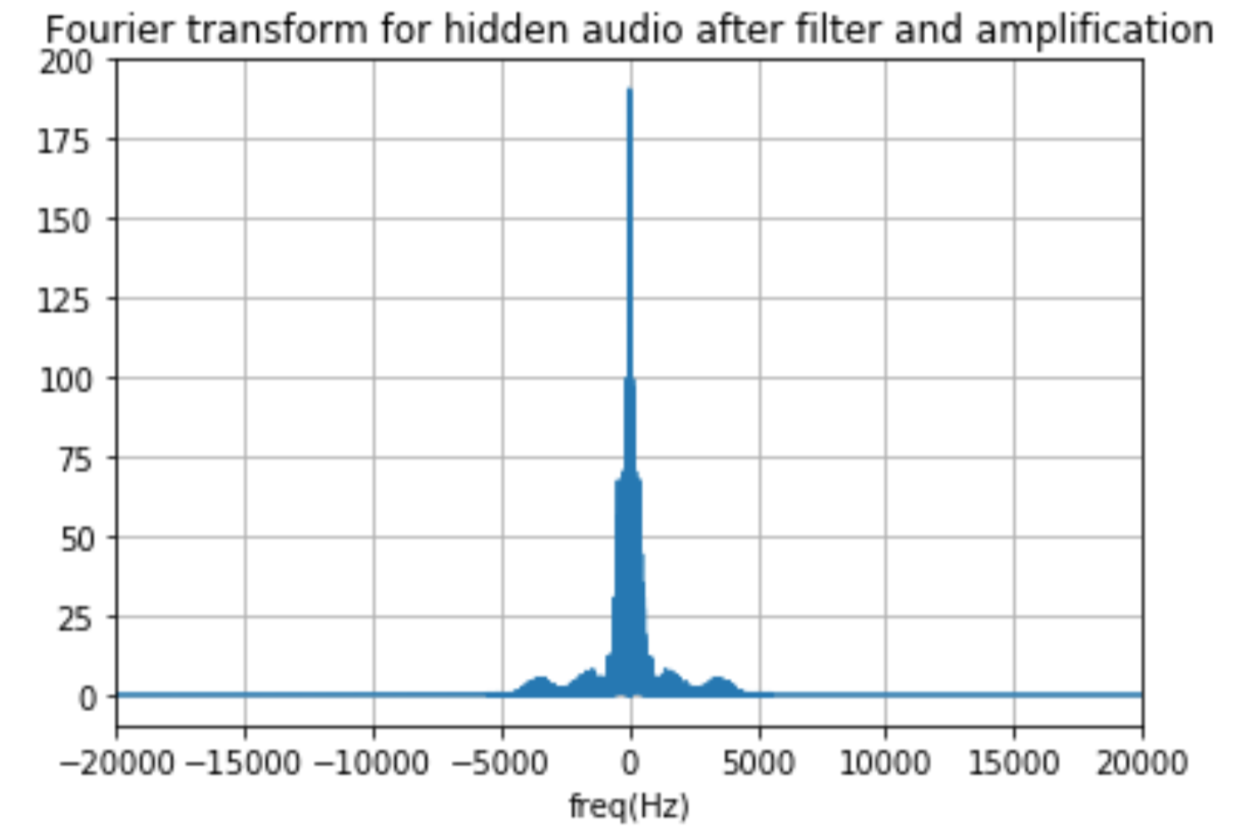

Figure 4

Audio steganography

## Task Three: Image compression

* See the appendix C for the code and info about how to run it
* GitHub link for the code: <https://github.com/marait123/Signals-Final/tree/master/3rd-task>
* The shown figures are the decompressed images after compressing with m from 1 to 4

Figure 5

Image compressed with m = 1

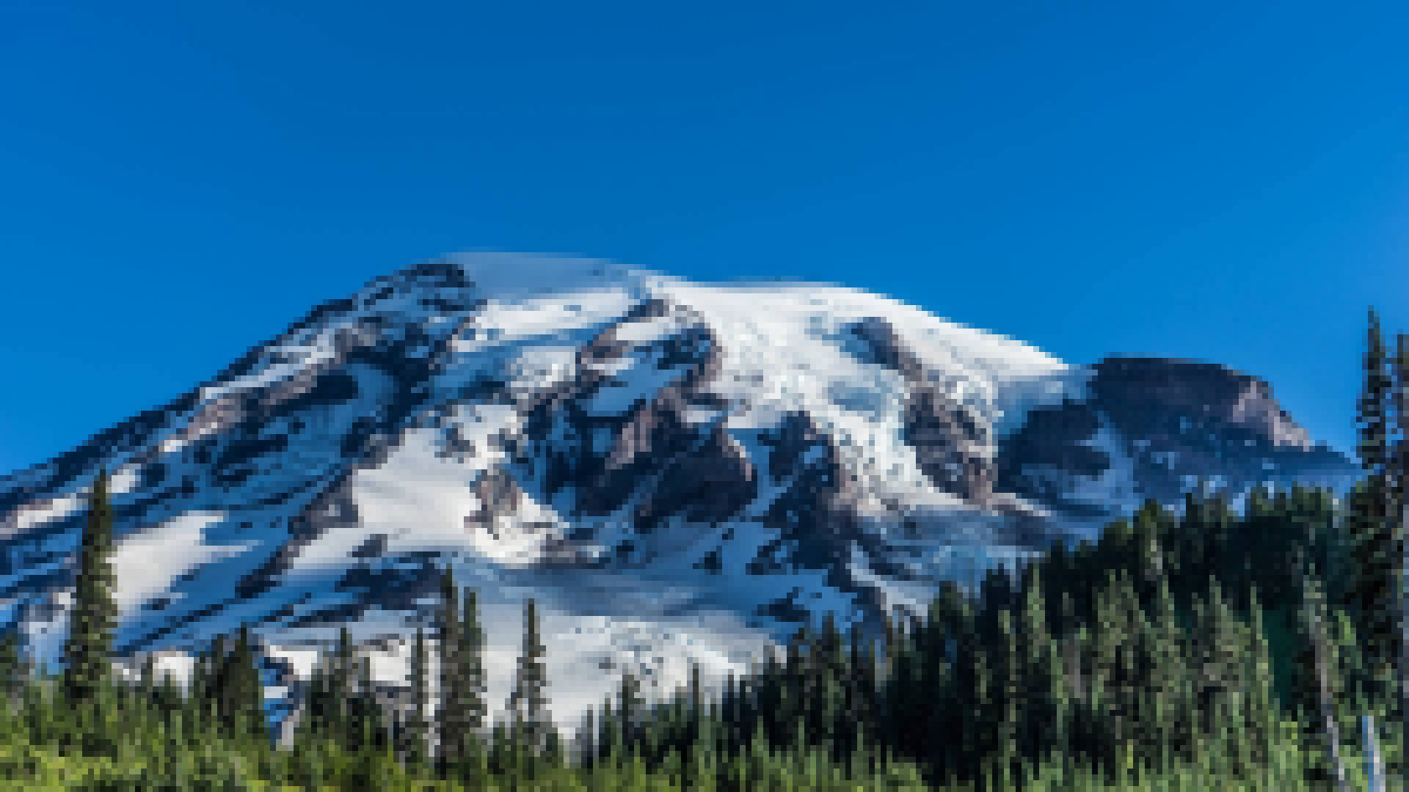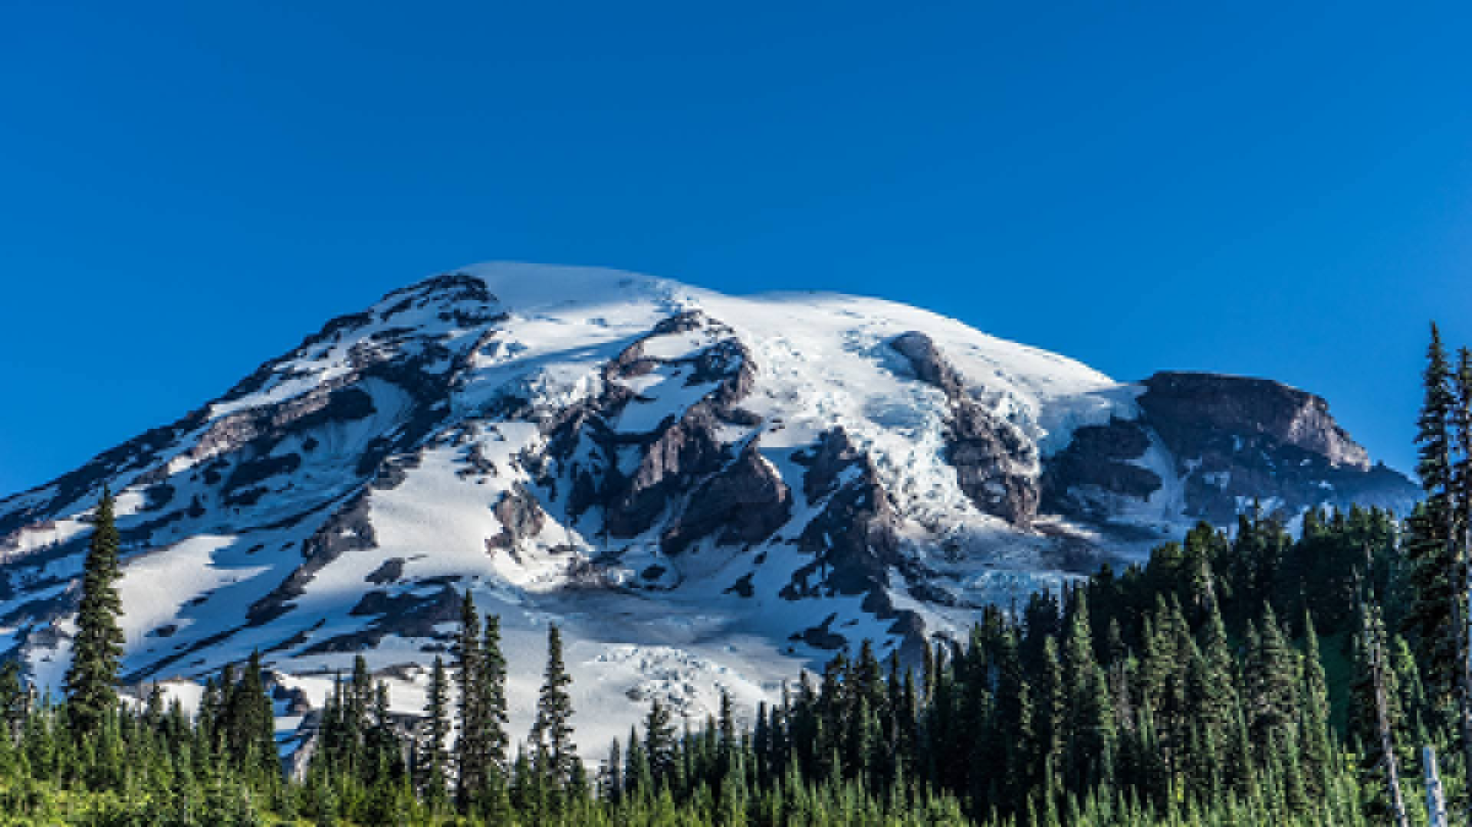

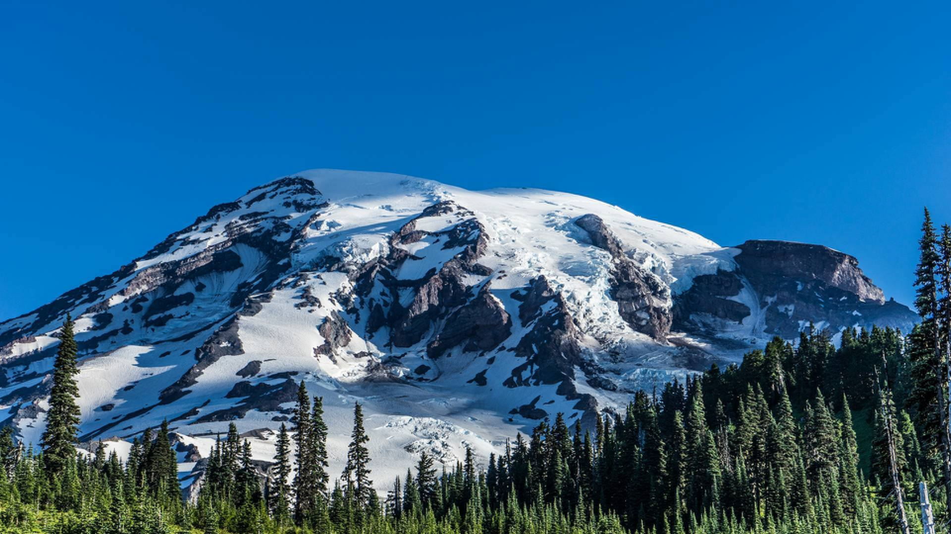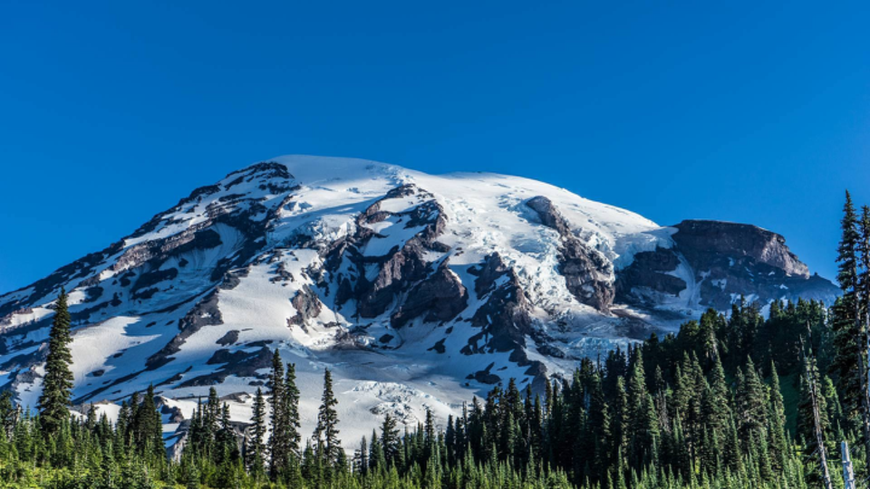

Figure 8

Image compressed with m = 4

Figure 7

Image compressed with m = 3

Figure 6

Image compressed with m = 2

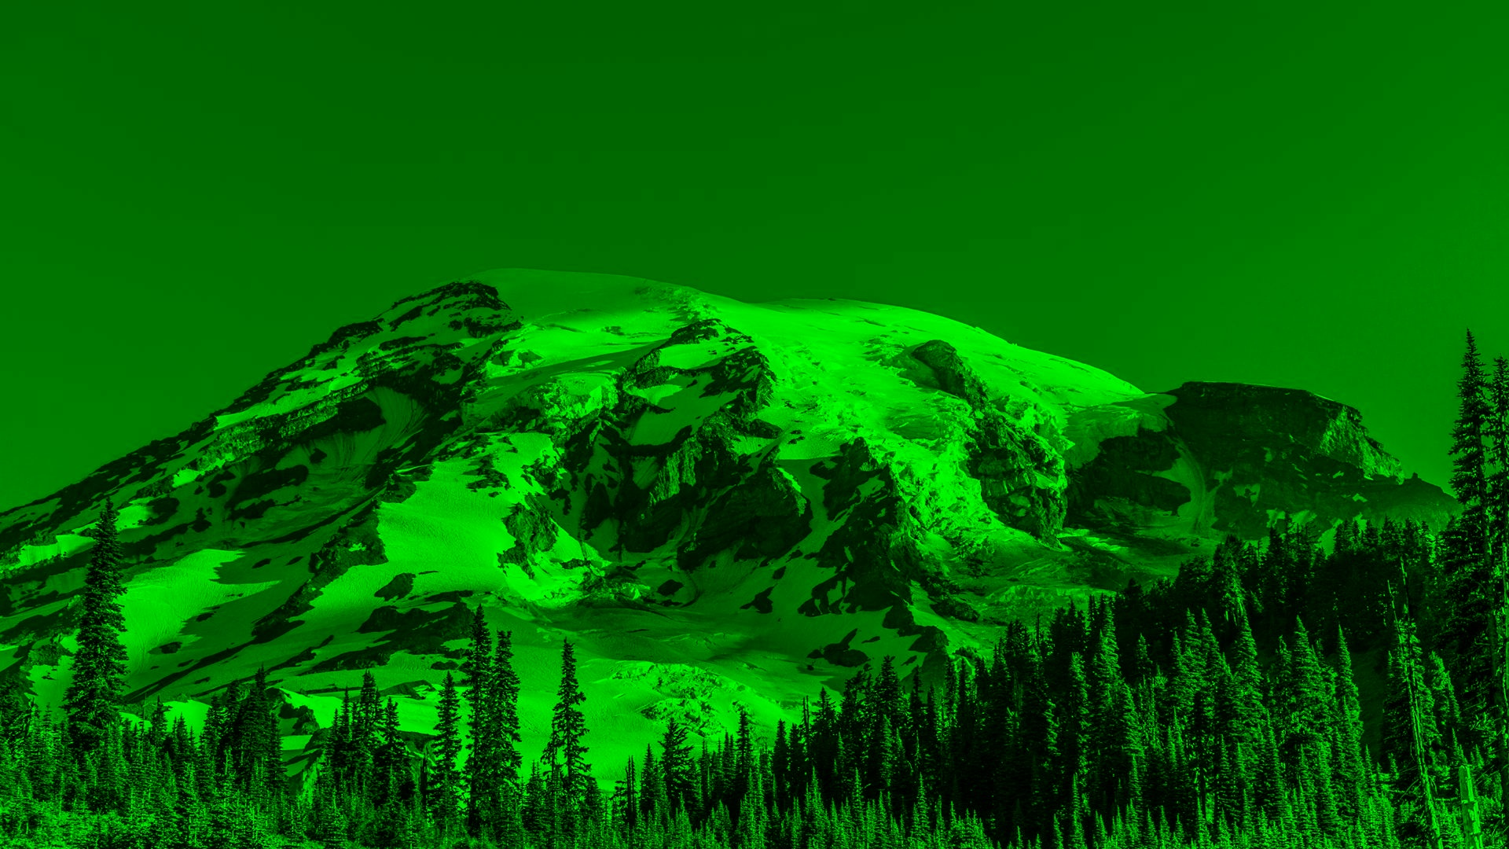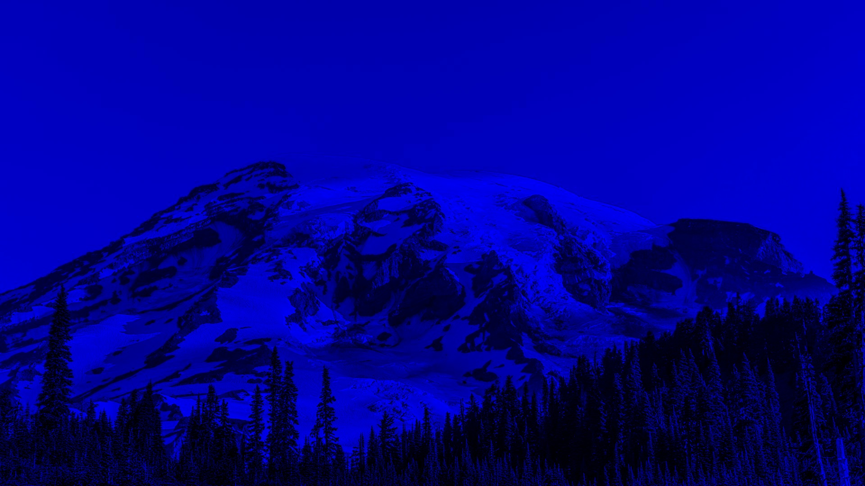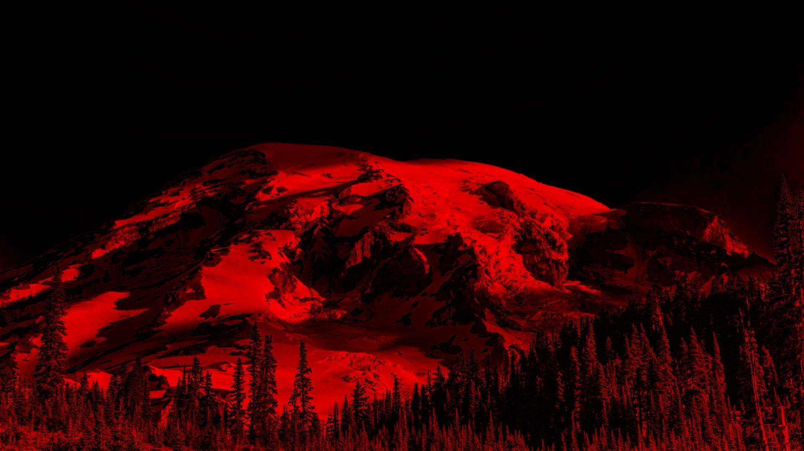Task 3 results:

Figure 9

Three components of image red, green and blue from left to right.

c:

Original size: 6076 kb

|  |  |  |
| --- | --- | --- |
| m | Compressed size(kb) | Compression ratio |
| 1 | 190 | 31.979 |
| 2 | 760 | 7.995 |
| 3 | 1709 | 3.555 |
| 4 | 3038 | 2 |

e:

|  |  |
| --- | --- |
| m | PSNR |
| 1 | 31.511456104971586 |
| 2 | 32.09103107097916 |
| 3 | 32.58914764270357 |
| 4 | 33.24307114876657 |

Task 3 answers:

f:

Advantages of DCT over DFT in compression:-

1- DCT provides better energy compacting for images which means that it packs information or energy in fewer coefficients and the other coefficients can be discarded.

2- DCT has real numbers and DFT has complex numbers this means that calculations with DCT will be easier and faster.

# Appendices

## Appendix A: Codes for Task One: (“<https://github.com/marait123/Signals-Final/tree/master/1st-task>”)

from scipy.io import wavfile

import numpy as np

import sounddevice as sd

import time

import matplotlib.pyplot as plt

from scipy import fft,ifft

duration_s = 4

# a. read the the file audio1.wav

fs, audio = wavfile.read('./audio1.wav')

# let's add echo to the sound

# impulse response has 2001

# b. find y(t) = x(t)+.9 * x(t-.25) + .8 * x(t-.5) + .7 * x(t-.75)

audioLength = len(audio)

secondSize = fs

x25 = np.zeros(audioLength + fs)

x25[int(.25 * fs):int(audioLength + .25 * fs)] = .9 * audio

x50 = np.zeros(audioLength + fs)

x50[int(.5 * fs):int(audioLength + .5 * fs)] = .8 * audio

x75 = np.zeros(audioLength + fs)

x75[int(.75 * fs):int(audioLength + .75 * fs)] = .7 * audio

y = (list(audio) + list(np.zeros(fs))) + x25 + x50 + x75

sd.play(y[0:audioLength].astype(np.dtype('i2')), fs)

plt.title('audio with and before echo ')

plt.xlabel('sample number')

plt.ylabel('amplitude')

plt.plot(y, label = 'y(t)')

plt.plot(audio, label = 'x(t)')

plt.legend()

plt.savefig('audio with and before echo.png')

plt.show()

time.sleep(duration_s)

#output the audio_with_echo_after_using_given_formula.wav

wavfile.write("audio_with_echo_after_using_given_formula.wav",fs,y[0:audioLength].astype(np.dtype('i2')))

# C. find and plot the impulse response of the echo generation system

# h is the impluse response of the system

h = np.zeros(secondSize)

h[int(0 * secondSize)] = 1

h[int(.25 * secondSize)] = .9

h[int(.5 * secondSize)] = .8

h[int(.75 * secondSize)] = .7

# plot h

plt.title('impulse response')

plt.xlabel('sample number')

plt.ylabel('amplitude')

plt.plot(h, label = 'h(t)')

plt.legend()

#output impulse_response.png

plt.savefig('impulse_response.png')

plt.show()

#ly=lx+lh-1

h_len=len(h)

audio_len=len(audio)

N=len(audio)+len(h)-1

h=list(h)+list(np.zeros(N-len(h)))

h=np.array(h)

audio=list(audio)+list(np.zeros(N-len(audio)))

audio=np.array(audio)

#convolve the audio with the impulse response to generate echo

echoedAudio = np.convolve(audio, h)

sd.play(echoedAudio[0:audioLength].astype(np.dtype('i2')), fs)

time.sleep(duration_s)

#output the audio_with_echo_after_convolution.wav

wavfile.write("audio_with_echo_after_convolution.wav",fs,echoedAudio[0:audioLength].astype(np.dtype('i2')))

#get x[n] given y[n](echoedAudio) and h[n] (h)

xn_fft=fft(echoedAudio,N)/fft(h,N)

xn=ifft(xn_fft)

xn=np.real(xn)

xn=np.around(xn)

xn=np.array(xn)

xn=xn[0:audioLength]

xn=xn.astype(np.dtype('i2')) # xn is the sound after echo removal

sd.play(xn, fs)

time.sleep(duration_s)

#output the audio_after_echo_removal.wav

wavfile.write("audio_after_echo_removal.wav",fs,xn)

**How to run task1?**

To run the code you need to do the following

1. Install python3.7
2. Install the following packages (matplolib, sound device, scipy, nump), to install run the packages
   1. pip install matplotlib
   2. pip install sounddevice
   3. pip install numpy
   4. pip install scipy
3. After installation
   1. Run python soundEcho.py (make sure current terminal in the folder of task 1 if you are using terminal to run it.)

## Appendix B: Codes for Task Tow: (“<https://github.com/marait123/Signals-Final/tree/master/2nd-task>”)



# coding: utf-8  
  
# # Audio Steganograpghy  
# ----------  
  
  
  
import matplotlib.pyplot as plt  
from scipy.io import wavfile as wav  
from scipy.fftpack import fft, ifft, fftfreq, fftshift  
import numpy as np  
import IPython.display as ipd  
from scipy.signal import resample_poly  
from fractions import Fraction  
  
  
  
  
def filterHighFreq(signalData):  
 dataAfterFilterFt = fft(signalData)  
 for i in range(1*int(dataAfterFilterFt.size/8),7*int(dataAfterFilterFt.size/8)):  
 dataAfterFilterFt[i]=0  
   
 return ifft(dataAfterFilterFt).real  
  
def our_resample(audio_data, old_rate, new_rate):  
 ratio = Fraction(new_rate, old_rate)  
 return resample_poly(audio_data, ratio.numerator, ratio.denominator)  
  
  
# ## Preparing  
# ---  
  
# ### Reading the audio files  
  
  
  
rate2, data2 = wav.read("audio2.wav")  
data2 = filterHighFreq(data2)  
  
total_samples2 = len(data2)  
sample_spacing2 = 1/rate2  
duration2 = total_samples2*sample_spacing2 # seconds  
  
  
  
ipd.Audio(data2, rate=rate2) # Audio player  
  
  
# In[4]:  
  
  
rate1, data1 = wav.read("audio1.wav")  
  
  
  
total_samples1 = len(data1)  
sample_spacing1 = 1/rate1  
duration1 = total_samples1*sample_spacing1 # seconds  
  
data1 = our_resample(data1,rate1,rate2)  
  
rate1=rate2  
total_samples1 = len(data1)  
sample_spacing1 = 1/rate1  
duration1 = total_samples1*sample_spacing1 # seconds  
  
data1 = filterHighFreq(data1)  
  
  
ipd.Audio(data1, rate=rate1) # Audio player  
  
  
plt.title("audio1")  
x1 = np.linspace(0, duration1, total_samples1)  
plt.plot(x1, data1)  
plt.xlabel('Time(sec)')  
plt.grid()  
plt.show()  
  
plt.title("audio2")  
x2 = np.linspace(0, duration2, total_samples2)  
plt.plot(x2, data2)  
plt.xlabel('Time(sec)')  
plt.grid()  
plt.show()  
  
  
# ### Fourier transform  
  
ft1 = fft(data1)  
y_ft1 = 1/total_samples1 * np.abs(fftshift(ft1))  
x_ft1 = fftfreq(total_samples1, sample_spacing1)  
x_ft1 = fftshift(x_ft1)  
  
ft2 = fft(data2)  
y_ft2 = 1/total_samples2 * np.abs(fftshift(ft2))  
x_ft2 = fftfreq(total_samples2, sample_spacing2)  
  
x_ft2 = fftshift(x_ft2)  
  
plt.title("Fourier transform for audio1")  
plt.plot(x_ft1, y_ft1)  
plt.xlabel('freq(Hz)')  
plt.xlim(-6000,6000)  
plt.grid()  
plt.show()  
  
plt.title("Fourier transform for audio2")  
plt.plot(x_ft2, y_ft2)  
plt.xlabel('freq(Hz)')  
plt.xlim(-6000,6000)  
plt.grid()  
plt.show()  
  
  
# ## Hiding "audio1" in "audio2"  
# ---  
  
  
  
  
  
omega = 2.4  
attenuationFactor = 0.01  
  
data3 = np.array(data2)  
  
for i in range(data1.size):  
 data3[i] =data2[i]+ attenuationFactor* data1[i] * np.cos(i*omega)  
  
  
   
ft3 = fft(data3)  
y_ft3 = 1/total_samples2 * np.abs(fftshift(ft3))  
x_ft3 = fftfreq(total_samples2, sample_spacing2)  
x_ft3 = fftshift(x_ft3)  
  
plt.title("Fourier transform for the compined Audio")  
plt.plot(x_ft3, y_ft3)  
plt.xlabel('freq(Hz)')  
plt.xlim(-25000,25000)  
plt.grid()  
plt.show()  
  
plt.title("Fourier transform for audio2")  
plt.plot(x_ft2, y_ft2)  
plt.xlabel('freq(Hz)')  
plt.xlim(-25000, 25000)  
plt.grid()  
plt.show()  
  
  
  
# ---  
  
  
  
  
ipd.Audio(data3, rate=rate1) # Audio player  
  
  
  
  
wav.write('audio3.wav', int(rate1), (data3).astype(np.int32)) # exporting the audio file  
  
  
# ## Restore audio  
  
  
  
combinedMessageRate , combinedMessage = wav.read("audio3.wav")  
  
hiddenAudio = np.array(combinedMessage)  
  
for i in range(data3.size):  
 hiddenAudio[i] = hiddenAudio[i]*np.cos(i*omega)  
   
   
hiddenAudioFt = fft(hiddenAudio)  
y_hiddenAudioFt = 1/total_samples2 * np.abs(fftshift(hiddenAudioFt))  
x_hiddenAudioFt = fftfreq(total_samples2, sample_spacing2)  
x_hiddenAudioFt = fftshift(x_hiddenAudioFt)  
  
  
plt.title("Fourier transform for hidden audio")  
plt.plot(x_hiddenAudioFt, y_hiddenAudioFt)  
plt.xlabel('freq(Hz)')  
plt.xlim(-20000, 20000)  
plt.grid()  
plt.show()  
  
  
# ## apply filter and amplify signal  
  
  
  
hiddenAudioAfterFilter = filterHighFreq(hiddenAudio/attenuationFactor)  
hiddenAudioAfterFilterFt= fft(hiddenAudioAfterFilter)  
  
y_hiddenAudioAfterFilterFt = 1/total_samples2 * np.abs(fftshift(hiddenAudioAfterFilterFt))  
x_hiddenAudioAfterFilterFt = fftfreq(total_samples2, sample_spacing2)  
x_hiddenAudioAfterFilterFt = fftshift(x_hiddenAudioAfterFilterFt)  
  
  
plt.title("Fourier transform for hidden audio after filter and amplification")  
plt.plot(x_hiddenAudioAfterFilterFt, y_hiddenAudioAfterFilterFt)  
plt.xlabel('freq(Hz)')  
plt.xlim(-20000, 20000)  
plt.grid()  
plt.show()  
  
hiddenAudioAfterFilter = np.fft.ifft(hiddenAudioAfterFilterFt).real  
  
  
  
  
ipd.Audio(hiddenAudioAfterFilter, rate=rate2)   
  
  
  
  
wav.write('hiddenMessage.wav', int(rate2), (hiddenAudioAfterFilter).astype(np.int16))

**How to run task2?**

1. Clone our repository from github “<https://github.com/marait123/Signals-Final>”.
2. Go to “<https://www.anaconda.com/products/individual#windows>” to download the anaconda installer for your operating system, then install it.
3. If you’re on mac or linux, open the terminal. If you’re on windows, it’s highly recommended to use Anaconda Prompt (Already installed with anaconda).
4. In the terminal navigate to the folder containing the repository, then type “jupyter notebook” and press enter.
5. A new browser window will show up. Open the folder named “2nd-task”, then click on “Audio Steganograpghy.ipynb”.

## Appendix C Codes for Task Three: (“<https://github.com/marait123/Signals-Final/tree/master/3rd-task>”)

*from* scipy.fft *import* dct, idct

*import* cv2

*import* utils

*import* numpy as np

*# part A: done read the image and display each of its components*

image = cv2.imread('image1.bmp')

utils.imgDisplay('OriginalImage', image)

imgRedComponent = utils.getImageComponent('red', image)

utils.imgDisplay("red", imgRedComponent)

imgBlueComponent = utils.getImageComponent('blue', image)

utils.imgDisplay("blue", imgBlueComponent)

imgGreenComponent = utils.getImageComponent('green', image)

utils.imgDisplay("green", imgGreenComponent)

*for* m in [1,2,3,4]:

*# Compress the image*

  compressedImage = utils.compress(image, m)

  np.save('image1.npy', image)

  np.save('decompressedm{}.npy'.format(m), compressedImage)

  decompressedImage = utils.decompress(compressedImage, m)

  cv2.imwrite('decompressedm{}.bmp'.format(m), decompressedImage)

  utils.imgDisplay('OriginalImage', decompressedImage)

  imgRedComponent = utils.getImageComponent('red', decompressedImage)

  utils.imgDisplay("red", imgRedComponent)

  imgBlueComponent = utils.getImageComponent('blue', decompressedImage)

  utils.imgDisplay("blue", imgBlueComponent)

  imgGreenComponent = utils.getImageComponent('green', decompressedImage)

  utils.imgDisplay("green", imgGreenComponent)

*#find and show the psnr*

  psnr = 255 ** 2

  psnr = psnr / (np.square(np.subtract(image, decompressedImage)).mean())

  psnr = 10 * np.log10(psnr)

  print("at m="+str(m)+" PSNR="+str(psnr))

*import* cv2

*import* numpy as np

RGB = {'blue': 0, 'green': 1, 'red': 2}

def getImageComponent(compName, imageMat):

    """

    @summary: returns the image with all other components set to zero except the one needed

    """

    b = imageMat.copy()

*# set green and red channels to 0*

*for* i in range(3):

*if* (i == RGB[compName.lower()]):

*continue*

        b[:, :, i] = 0

*return* b

def imgDisplay(imageName, imageMat):

    cv2.imshow(imageName, imageMat)

    cv2.waitKey(0)

    cv2.destroyAllWindows()

*# A function that calculates the dct transform of a given matrix*

def blockDct(block):

*return* dct(dct(block.T, norm='ortho').T, norm='ortho')

*# A function that calculates inverse dct of a matrix*

def blockIdct(block):

*return* idct(idct(block.T, norm='ortho').T, norm='ortho')

*# A function that compresses images*

def compress(image, m):

*# Extract the number of columns and rows from the dimensions of the image*

    rows, cols, = image.shape[0:2]

*# Calculating the dimensions of the new array and initialzing it*

    newrows = rows / 8 * m

    newcols = cols / 8 * m

    compressed = np.zeros((int(newrows), int(newcols), 3), dtype=np.float16)

*# Changing range of values from 0-255 to (-128)-127*

    image = image.astype('int16') - 128

*# Calculating DCT for the image*

*# we calculate the DCT by slicing an 8x8 matrix and calculate its DCT matrix*

*# and then slicing the top left mxm matrix from each block*

*for* i in range(0, int(rows/8)):

*for* j in range(0, int(cols/8)):

*for* k in range(3):

*# Calculating the indices on the compressed image*

                newy = i*m

                newx = j*m

*# calculating the indices on the original image*

                oldx = j*8

                oldy = i*8

*# Calculating the dct*

                sliced = blockDct(image[oldy:oldy+8, oldx:oldx+8, k])

*# Slicing the top left mxm matrix*

                sliced = sliced[0:m, 0:m]

*# Assiging the new dct values to the new image*

                compressed[newy:newy+m, newx:newx+m, k] = sliced

*return* compressed

def decompress(compressed, m):

  rows, cols, = compressed.shape[0:2]

  originalRows = rows / m * 8

  originalCols = cols / m * 8

  original = np.zeros((int(originalRows), int(originalCols), 3), dtype=np.uint8)

**How to run task 3?**

To run the code, you need to do the following:

1. Install python 3.7
2. Install numpy, scipy and opencv packages, they can be installed using pip by the following commands:

* pip install numpy
* pip install scipy
* pip install opencv-python

1. After installation run main.py file in the task3 folder

*for* i in range(0, int(rows/m)):

*for* j in range(0, int(cols/m)):

*for* k in range(3):

        comx = j * m

        comy = i * m

        orgx = j * 8

        orgy = i * 8

        retrieve = np.zeros((8,8))

        retrieve[0:m,0:m] = compressed[comy:comy+m, comx:comx+m, k]

        retrieve = blockIdct(retrieve) + 128

        retrieve = retrieve.clip(min=0, max=255)

        original[orgy:orgy+8, orgx:orgx+8, k] = retrieve

*return* original

# 

# References:

1. Oppenheim Signals and Systems